Admin login link
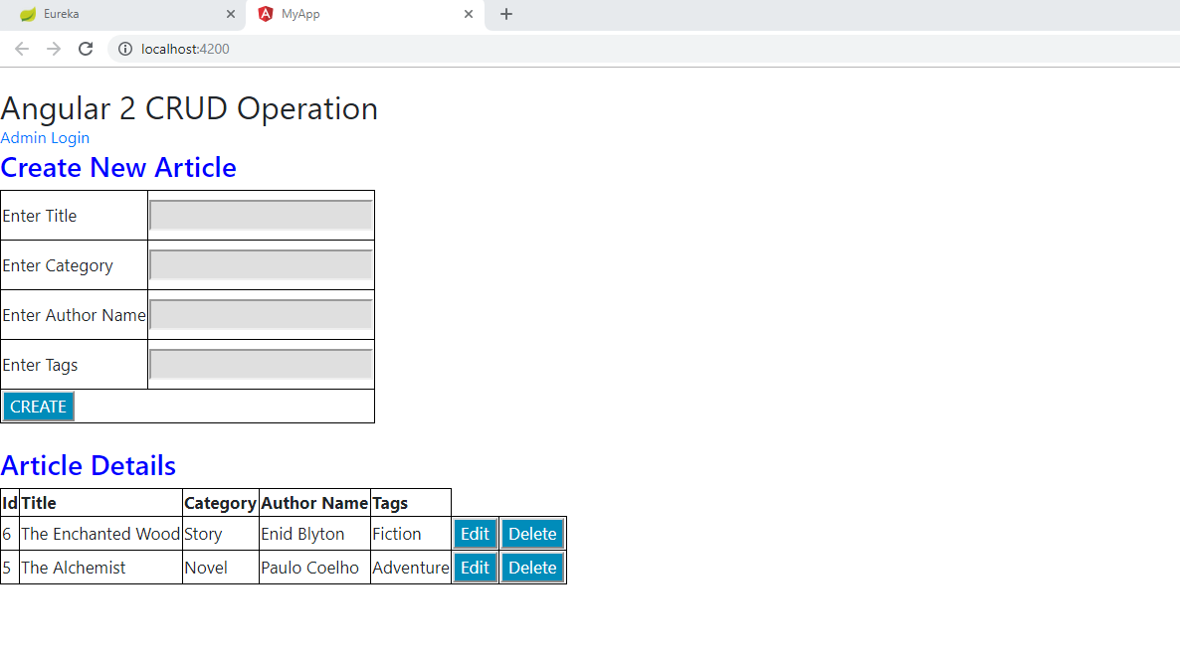
Admin login
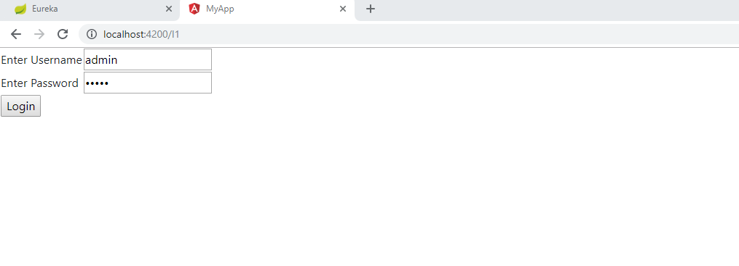
Admin having list of blocked and unblocked articles
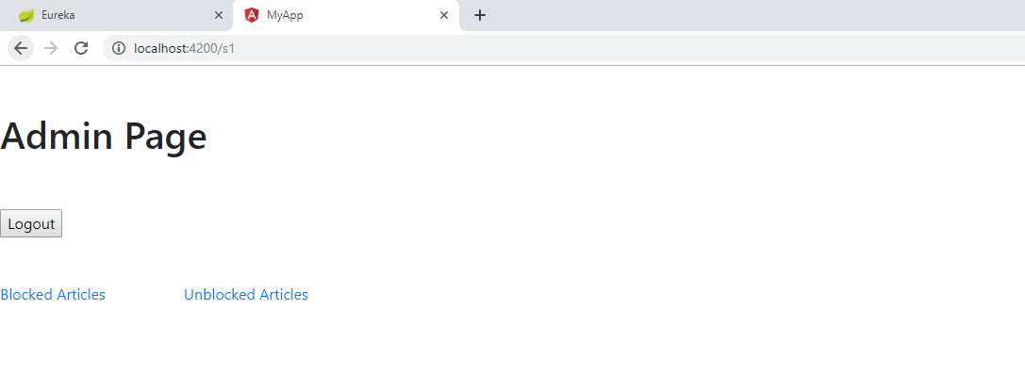
List of unblocked articles which admin can block
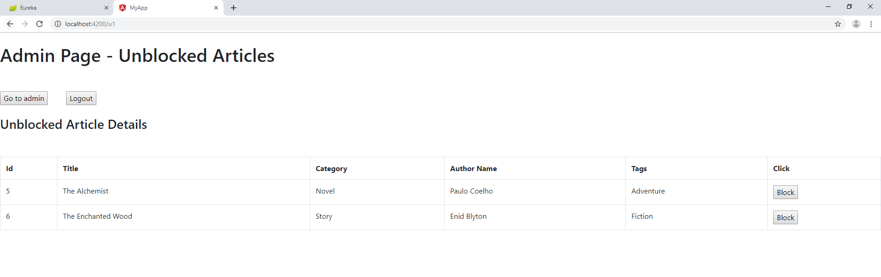
Blocking article “The Tempest”, will be removed from unblocked list and visible in blocked list, also will not be visible to the user.
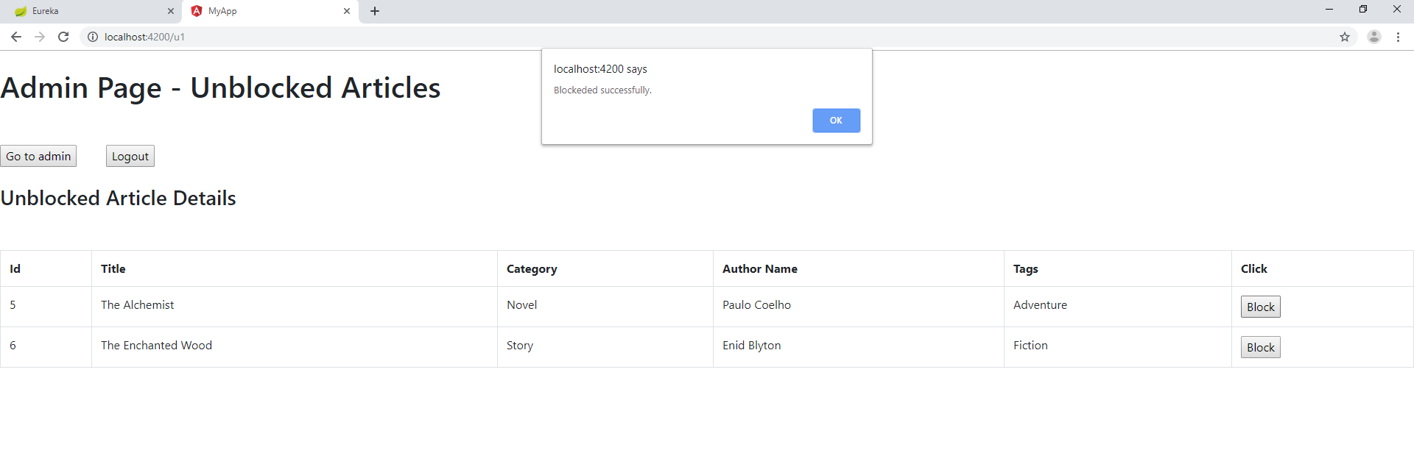
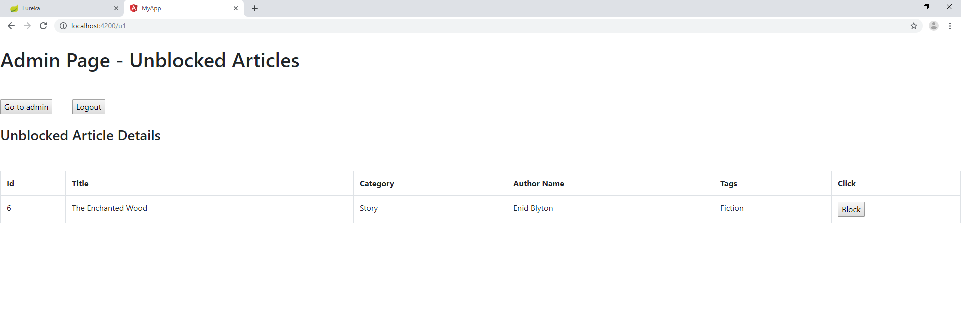
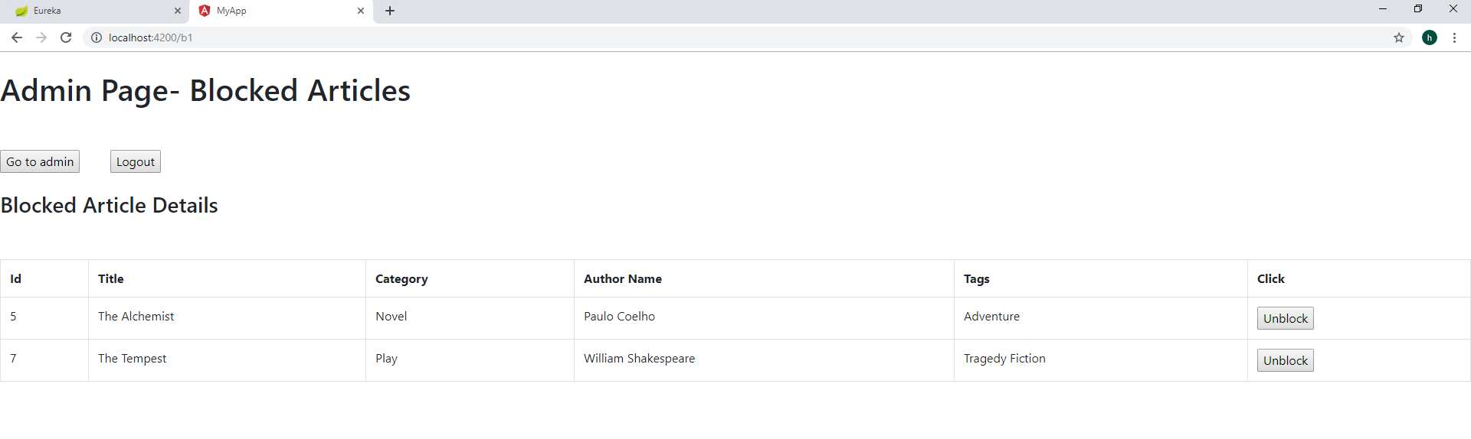
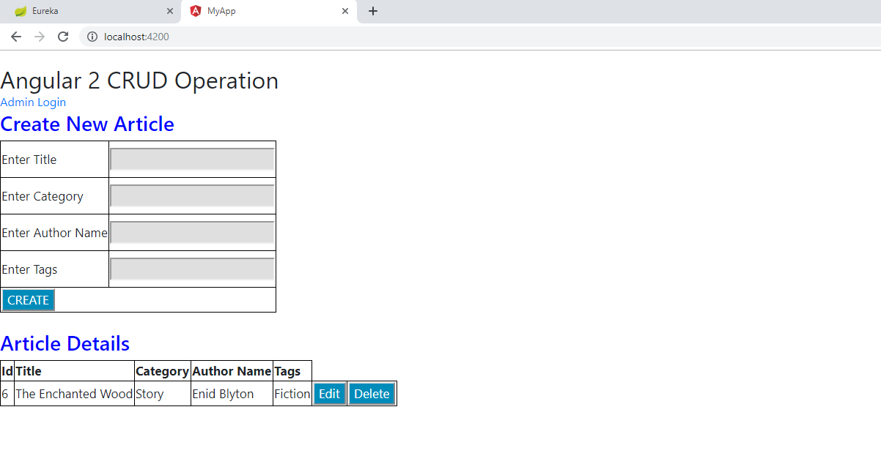
Unblocking article “The Tempest”, will be removed from blocked list, visible in unblocked list and also to the user.
